Solving Quadratic Equations Name: ______________________________________________

Solving By Factoring
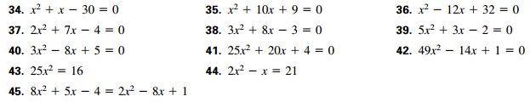

Solving by Square Roots
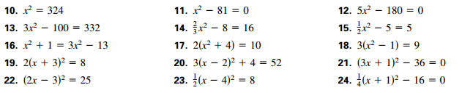

Solve by Quadratic Formula

Answers:
Solving By Factoring
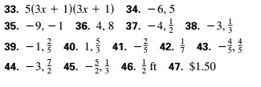

Solving by Square Roots
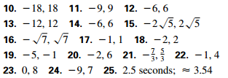

Solve by Quadratic Formula
